NEWSLETTER

AUTUMN

Welcome to the autumn newsletter. In this edition, we share some of the work that has happened across Lime Tree Surgery during the last 18 months.

Lime Tree Lockdown
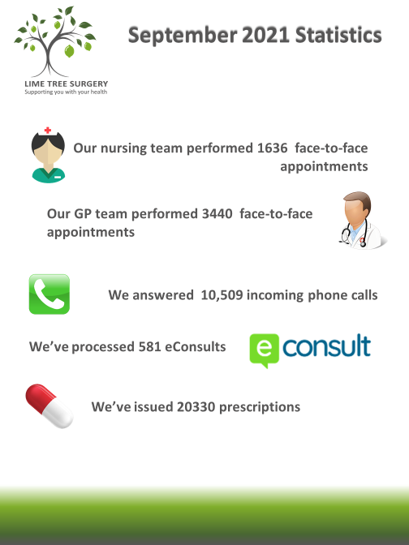
During the period of lockdown, we introduced a system of triaging all patient requests to see a physician. Many people were able to be helped by an online consultation, telephone consultation or were given a face to face appointment. In order to keep everyone safe, we limited the amount of people attending the practice by only allowing those with pre-booked appointments [and their carers if necessary]. All repeat prescription requests were processed electronically enabling patients to collect their medication directly from the pharmacy of their choice, or arrange with their pharmacy for a home delivery.
We volunteered our premises at Goring to serve the whole of Worthing as the “hot hub” where patients who had symptoms which could be due to covid 19 were seen by a duty clinician from one of the practices in Worthing. The hot hub was deep cleaned between each patient, and hot hub personnel confined to the area following strict infection control guidelines. Lime Tree Goring was zoned to try and reduce transmission of covid 19 and to protect staff and patients.
We took the opportunity to improve facilities for patients. At Findon we have had a consulting rooms 8, 13 and 15, and treatment room 2 refitted,and many of the public areas decorated. The guttering, fascia and wooden exterior panelling were replaced and the flat roof over the pharmacy has been renewed. We have had all of our clinical equipment tested and serviced, and had specialist companies attend to perform Fire Risk Assessments and Health & Safety Assessment on all 3 sites. The exterior of the building at Goring has been cleaned by a specialist company.
The Royal College of General Practice have developed the Green Impact for Health Toolkit. It is a guide to help practices become greener by making small changes. 5.4% of the UK’s carbon emissions are from the NHS. So far, Lime Tree Surgery has switched to eco-friendly cleaning products, have supplied an electric bicycle for staff use, and are currently looking at low carbon alternatives when prescribing, for example looking at ways of changing inhalers where possible to low carbon alternatives, have switched to paper from renewable sources.

.

Lime Tree Surgery Patient Participation Group (LTSPPG).
The next PPG meeting is a face to face meeting on Tuesday 9th November; 1-2pm.

We will be using Microsoft Teams to link the smart screens at Goring and Findon enabling participation from either site.

For those people who cannot attend in person, they can join the meeting from a PC or tablet using this link https://teams.microsoft.com/l/meetup-join/19%3ameeting_YzQxMThjZmEtZjk1My00NDJiLWE0NmItMTczMjZlOWUzZTYw%40thread.v2/0?context=%7b%22Tid%22%3a%2237c354b2-85b0-47f5-b222-07b48d774ee3%22%2c%22Oid%22%3a%2239e6689d-8731-42c9-9245-74e09da6e1b9%22%7d.

An ordinary land line can also be used to listen and comment. Call 020 3321 5208
you will then be asked for the conference PIN which is 855 248 294#

It is anticipated that we will continue to use Microsoft Teams link to PPG meetings enabling access to patients who are housebound, carers etc.

We are hoping using Teams will encourage greater involvement by patients and better use of meeting time.

An Easy Quick Start Guide for how to Join a Teams meeting on the web
Don't have the Teams app? You can still join a Teams meeting.
1. In your email invite, select Click here to join the meeting.
You can also use a dial-in number and conference ID from the email to call in.
2. You have three choices:
- Download the Windows app: Download the Teams desktop app.
- Continue on this browser: Join a Teams meeting on the web.
- Open your Teams app: If you already have the Teams app, go right to your meeting.
3. Type your name.
4. Choose your audio and video settings
5. Select Join now.
6. Depending on meeting settings, you'll get in right away, or go to a lobby where someone in the meeting will admit you.
Managing your settings while in a meeting
Once you have joined an MS Teams meeting,
· The Camera icon allows you to switch your camera on and off, if it is off then other participants will not be able to see you during the meeting
· The Microphone icon allows you to switch your microphone on and off, if you microphone is off then other participants will not be able to hear you
· The red/white telephone icon allows you to leave the meeting, if you click this icon you will leave the meeting, if you need to get back into the meeting you will need to re-join using the email invitation you were originally.
Ready to learn more?
Follow the link below to watch further training videos on Microsoft Teams: https://support.microsoft.com/en-us/office/microsoft-teams-video-training-4f108e54-240b-4351-8084-b1089f0d21d7

