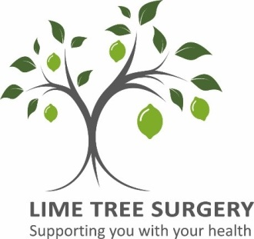
NEWSLETTER

WINTER 2020

Welcome to the winter newsletter. In this edition, we introduce members of our team you may not heard of before. They have been recruited by our Primary Care Network [PCN] under the Additional Roles Reimbursement Scheme [ARRS]. ARRS provides a great opportunity to increase access to care for our patients, for us to collaborate with other service providers and also increase the range and expertise of staff.
We also share how hard your practice has working for you during the first wave of Covid-19.

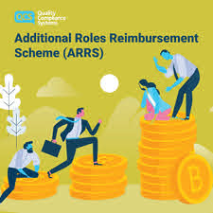
Jenny Powell and Bex Parton PCN Care Co-ordinators
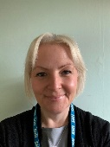
We are Jenny and Bex your PCN Care Co-Ordinator’s located at Lime Tree and The Barn Surgery. We are an information support and guidance service. Our aim is to ensure the patient feels supported and has access to local services that are right for them.
We currently support a group of patients coping with loneliness by contacting them each week to check in. We can also refer patients to our local befriending service where we can arrange volunteers to contact them as well. We have had some brilliant feedback from both these schemes.
We also help patients, Carers and families to avoid unplanned hospital admissions by working closely with the Proactive Care Team. This service has been set up to support people with long-term health conditions (frailty) and complex health and social needs. We want to improve the quality of the patients care and support them to manage their long-term needs to live as well and as independently as possible.
We encourage patients to contact us, finding support can be a daunting task but we can help them find the right path by providing information on a variety of local services.
Danny Bartlett PCN Clinical Pharmacist
I’m the Clinical Pharmacist for the GP practices in our network. I focus on day-to-day medication queries from patients, hospital letters and discharges, and also ensure all patients are monitored appropriately for the medications they are taking. I work with the GPs to make sure our Care Home residents in particular are looked after in terms of their medications too. Many of our patients have complicated medical needs requiring quite a few different medications to treat them and it’s my job to make sure they all work well together.

Estelle Day PCN Paramedic Practitioner

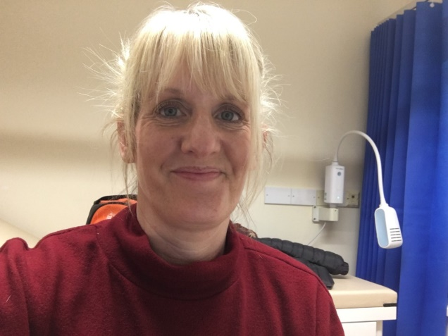
My role is to help triage patients by providing safe individualised patient care. To treat, refer and/or discharge patients safely. This will include some face to face examinations. I will also be carrying out home visits for our most vulnerable patients with acute, ongoing and complex health needs.

Ellie Lodge-Chilton, Social Prescriber, Adur & Worthing Councils

I’m Ellie and I am a Social Prescriber with Going Local. Going Local is a Social Prescribing Service which works alongside your GP surgery.
Social Prescribing gives a safe place to talk at length about any worries that might be affecting health and wellbeing. Life can be challenging sometimes - and when there's more than one hurdle, it can be difficult to know where to start. We support people to make positive changes in their life and within their communities by linking them to volunteers, activities, voluntary and community groups, and public services that can help. People might be worried about housing and finance, keen to find out about local courses or discover a new interest. Whatever they are looking to change in life, we can use our vast community knowledge to help people focus on what matters most. We accept self-referrals or from someone else, like a GP, other professional, friend or family member.
Paul Simpson, West Sussex MIND
My name is Paul Simpson and I’m a mental health support worker employed by West Sussex Mind. I’ve been holding regular mental health support clinics within the PCN since September 2019, providing telephone support to patients who are struggling to cope with stress, anxiety, depression or a personality disorder.
The aim is to improve individual coping skills, leading to greater patient independence and resilience – and less reliance on support from the surgery. The service is available to anyone aged 18 and above but is unable to support a patient in mental health crisis, or where a moderate/severe learning disability, brain injury or dementia is causing cognitive impairment, or where drug and alcohol use is the primary presenting concern. Despite these limitations I am always willing to discuss a potential referral prior to determining service suitability.

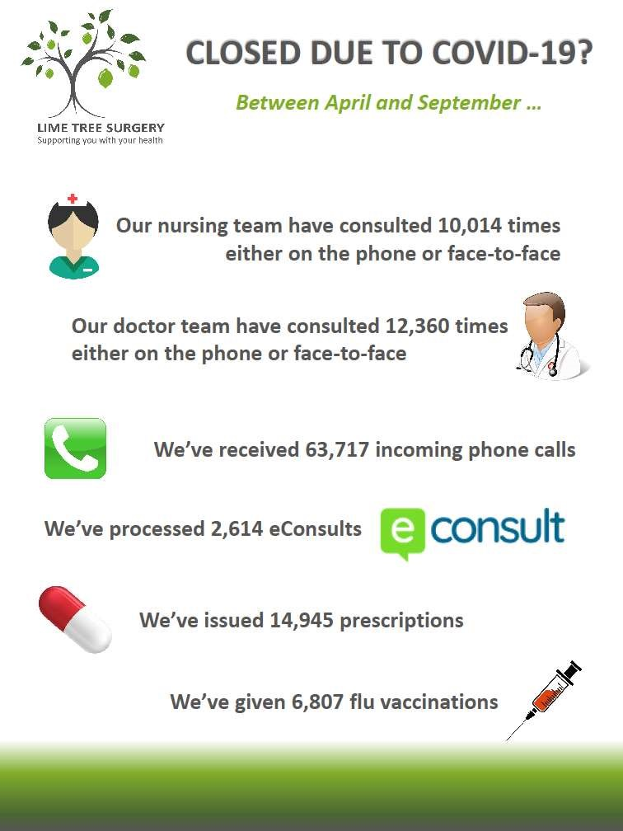

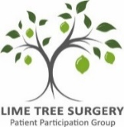
Welcome to the 2nd part of the introduction to the Lime Tree
Surgery Patient Participation Group (LTSPPG).
The role of the PPG has been disrupted, this year, by Covid-19 although we are now starting to hold patient meetings, with the practice management, using video conferencing (Zoom) to discuss topics such as patient flu vaccination & incorporation of Goring patients into the PPG. Minutes can be found on our website http://limetreesurgeryppg.org.uk/index.html
One thing that the PPG have been able to continue, during lockdown, is to ensure that the patient perspective is maintained by keeping patients informed on Practice, NHS West Sussex CCG activities and where possible express opinions, on these activities, on behalf of patients. The group have also been involved in helping develop and build a West Sussex based PPG network outside of the practice. Communication with our patients, in the community, has been kept through the local Findon and High Salvington Resident Associations as well as our LTSPPG website. http://limetreesurgeryppg.org.uk/index.html
One of the important PPG goals is the Health & Wellbeing of Lime Tree patients. Some of these activities have had to stop, for the time being, because of Covid-19 but were actively supported by patients before the break e.g. Keep Fit Exercise Group; “Strollers” Walking Group; supply of Health & Wellbeing literature. The PPG have some exciting ideas for future Health & Wellbeing projects (please see advert at the bottom of the page).
The PPG also actively promotes and supports groups & activities relevant to patients. Examples of these are “Ark”- Act of Random Kindness organised by All Saints Church, Findon; Bereavement Support – Sussex NHS Commission; Worthing Park Run – Saturday fun run or walk along Worthing sea front; Diabetic Care in-house; Type 2 Diabetes Education and Support through CCG (Peter Adamson, Lime Tree patient and Public Health Collaboration Ambassador for Worthing).
Finally, the PPG have a separate Charity group which raise money to buy items for the practice and patients which are not funded by the NHS. The charity covers all three sites, is run by Trustees and in the past have received donations from patients and money through our successful “Book Club.” The book club is shut at the moment but will reopen once the surgeries return to normal service.
All patients are PPG members and can keep up to date by registering their e-mail contact address or learn more about the group through: secretary@limetreesurgeryppg.org.uk
Next Lime Tree Surgery Patient Participation Group Meeting:
Tuesday 5th January 2021; 1-2pm via video conferencing (Zoom)

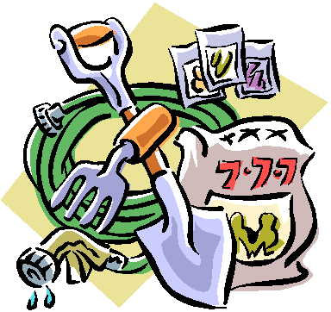
Keen Gardeners Wanted to help with Lime Tree Surgery PPG Wellbeing Project at the Surgery.
For more information please contact: secretary@limetreesurgeryppg.org.uk
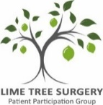
# YOUR PRACTICE/YOUR VOICE
Gardeners Wanted 1

